Arduino IDE
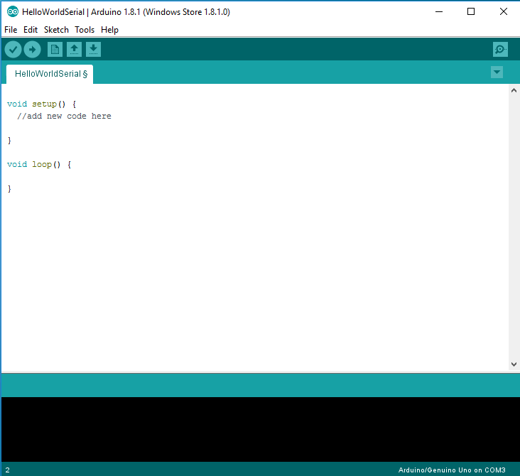

The Arduino Integrated Development Environment (IDE) is a suite of open source tools used to write, load, and run code for the Arduino. An Arduino program is referred to as a 'sketch.' Make sure your Arduino is connected to the computer using the USB cable, then open up the provided sketch Blank.ino.
This sketch, as currently written, doesn't actually do anything; but its still a valid program, so we can walk through the process of loading it onto the Arduino.

Start by pressing the verify button . This compiles the code; which means it takes the code you can edit, and turns it into a binary file the computer can execute. During this step, we will discover if our code contains any errors; if errors exist, the compilation will fail and the IDE will give you feedback on what went wrong.

Next, use the upload button to send this code to the Arduino. You should see the process complete, and the IDE will report that the upload is done. It should be noted that pressing upload automatically verifies your code before uploading; so when you’re ready to upload you don’t need to press verify first.

